GitHub Account, MFA Setup and Video Commands – Practical Notes
Objective: To watch the assigned video, prepare notes, create a GitHub account, configure Multi-Factor Authentication (MFA) using a mobile authenticator app, and execute all commands demonstrated in the video.

Create a GitHub Account
GitHub is a platform used to host Git repositories and collaborate on software projects.
1. Open a web browser and go to https://github.com/.
2. Click Sign up.
3. Enter your email address and create a secure password.
4. Choose an available GitHub username.
5. Complete the verification steps requested by GitHub.
6. Verify your email address using the verification email sent by GitHub.
7. Complete the initial account setup if prompted.
8. Sign in to the newly created GitHub account. 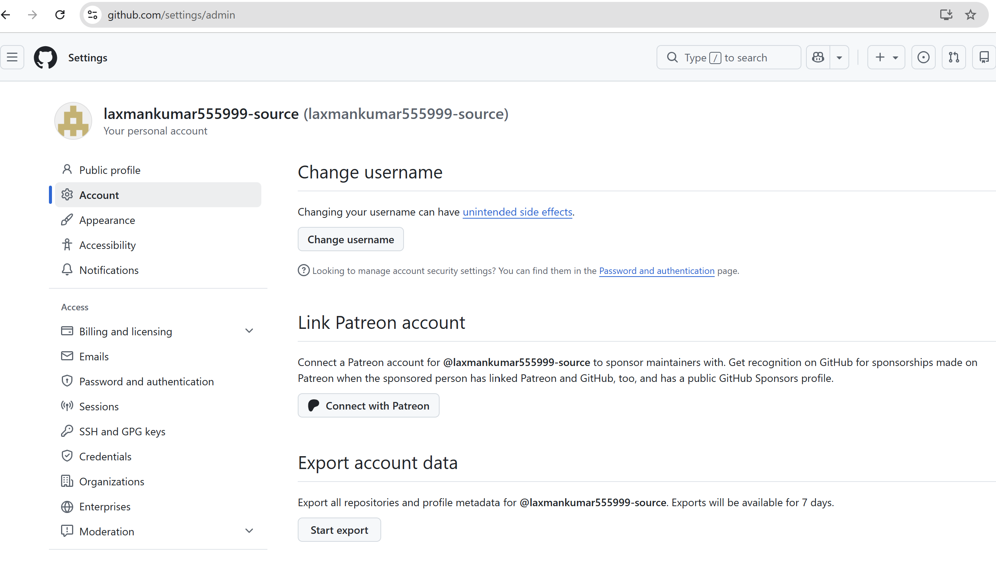

Account Verification Checklist
- GitHub account has been created.
- Email address has been verified.
- GitHub username is available and working.
- User can successfully sign in.
- GitHub profile page can be opened.

Set Up MFA Using a Mobile App
Multi-Factor Authentication (MFA), also commonly called two-factor authentication (2FA), adds an additional verification step when signing in. An authenticator app on a mobile phone can generate time-based verification codes.

Prerequisites
- A working GitHub account.
- A mobile phone.
- An authenticator application such as Google Authenticator or Microsoft Authenticator.
- Access to the GitHub account and its security settings.

MFA Setup Steps
1. Sign in to GitHub.
2. Open the account Settings.
3. Open Password and authentication or the security/authentication section.
4. Locate Two-factor authentication (2FA).
5. Choose an authenticator app as the authentication method.
6. Install an authenticator app on the mobile phone if one is not already installed.
7. Use the authenticator app to scan the QR code displayed by GitHub, or enter the setup key manually if required.
8. The mobile app will generate a verification code.
9. Enter the current verification code into GitHub.
10. Complete the MFA setup.
11. Store the recovery codes in a secure location. Do not share them with anyone.
12. Sign out and test the login process to confirm that MFA is working. 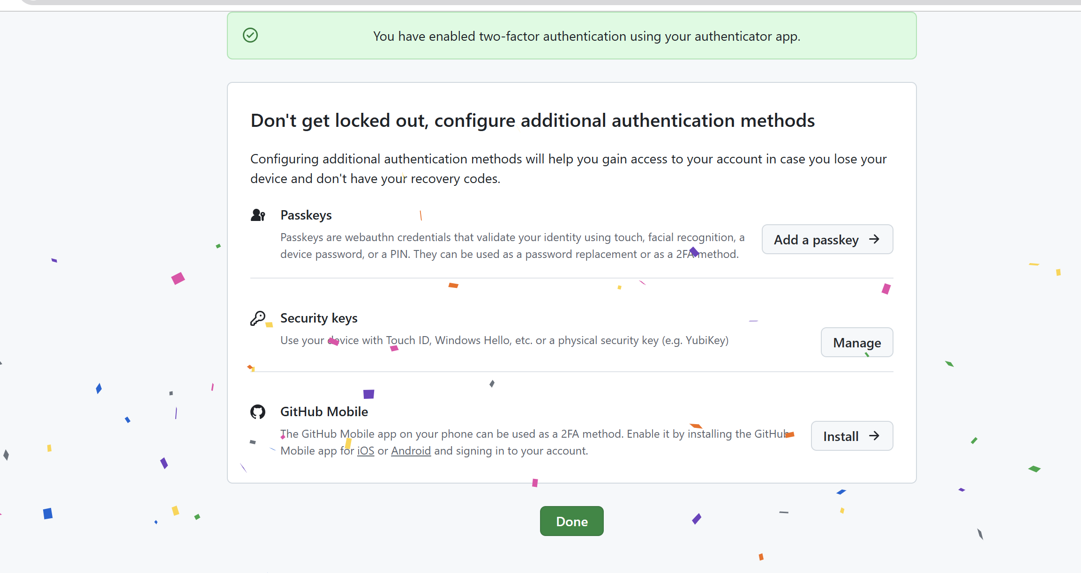

MFA Verification Checklist
- Authenticator app is installed on the mobile phone.
- GitHub is successfully linked to the authenticator app.
- A verification code is generated by the app.
- GitHub accepts the verification code.
- Recovery codes have been stored securely.
- MFA login has been tested successfully.

Important Security Notes
- Never share your GitHub password, MFA verification code, setup key, or recovery codes.
- Keep recovery codes in a secure location.
- Do not save recovery codes in a public GitHub repository.
- If your mobile device is lost or replaced, use the available recovery method to regain account access.

4. Execute All Commands Shown in the Video
After completing the GitHub account and MFA setup, execute every command demonstrated in the assigned video. Use the exact command syntax shown in the video and verify the output.

Execution Procedure
1. Open the terminal or command-line environment used in the video.
2. Review the command before executing it.
3. Execute the command exactly as demonstrated.
4. Observe and record the command output.
5. Confirm whether the command completed successfully.
6. If an error occurs, record the error message and troubleshoot it.
7. Continue with the next command only after understanding the previous step.
8. Take screenshots of important commands and successful results.
9. Compare your output with the output demonstrated in the video. 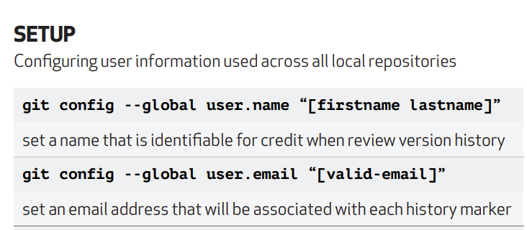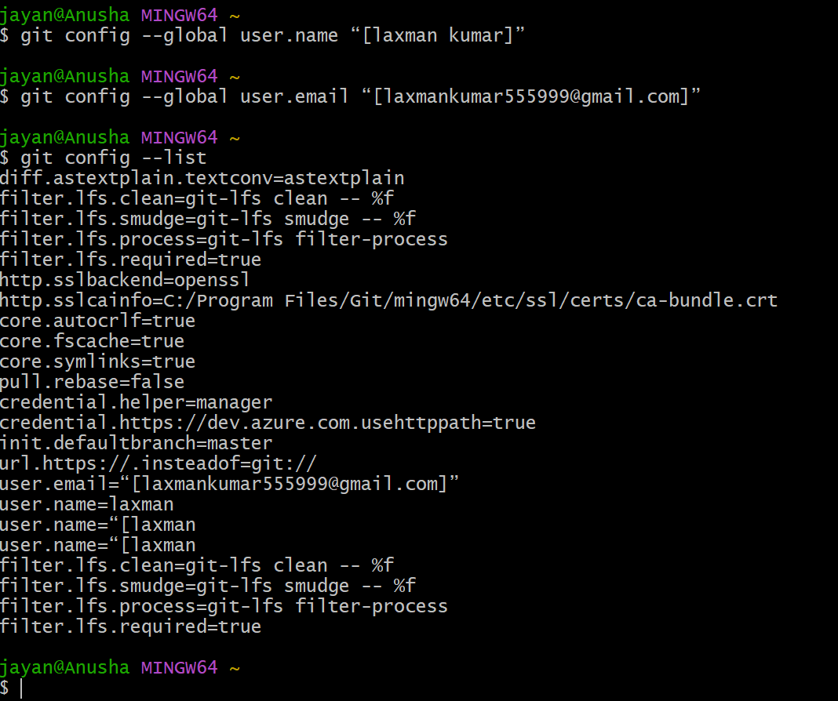
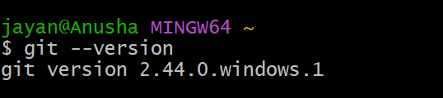

Conclusion
This practical exercise provides experience with GitHub account creation, account security using MFA, and command-line execution. Completing all the steps and documenting the results helps build a reliable record of the practical work performed.

